**Long Run Aggregate Supply and Output Gaps Activity**

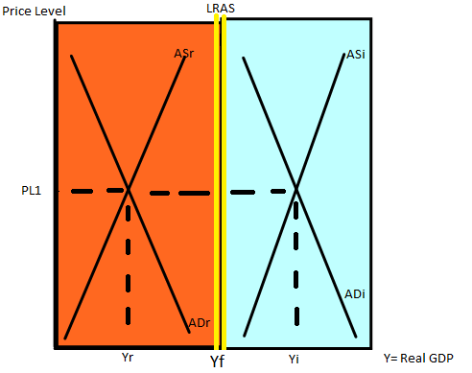

**Key**

Yf= Full Employment GDP Output AD= aggregate demand

r= recession AS= aggregate supply

i= inflation

LRAS= long run aggregate supply

***Directions***: For each of the following scenarios answer with an **r** for recessionary gap , **i** for inflationary, or an **f** for at full employment. The full employment line is in the middle outlined in yellow.

1. At point PL1, Yi the gap is ______
2. At point PL1, Yr the gap is ______
3. The period in which wages and other price changes are flexible ______
4. If output exceeds full employment ______
5. If real GDP exceeds potential GDP ______
6. If full employment exceeds real output ______
7. The economy is operating at its full capacity ______
8. If the GDP is greater than LRAS ______
9. If potential GDP falls short of real GDP ______
10. The economy is experiencing unemployment ______
11. The economy is overheating ______
12. All prices are rising relative to real output ______
13. The economy is operating inside of its PPF ______
14. Output is greater than Yf ______
15. Output is equal to the PPF ______
16. The national income is less than potential GDP ______

**Drawing Initial AS/AD Equilibrium in Relation to Full Employment**

***Directions***: Draw the appropriate Short Run Aggregate Supply and Aggregate Demand initial equilibrium for each of the following scenarios and label it ${PL}_{1}$ and $Y_{1}$**.** Assume the Natural Rate of Unemployment is **5%** for each graph and the acceptable rate of inflation for each country is **3%.**

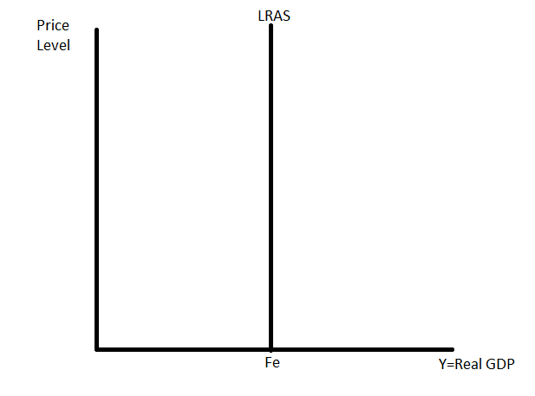 

1. Unemployment is at 8%. 2. Inflation is at 6%.

 

3. The economy is operating at full employment. 4. The economy is in recession at short run

equilibrium.

 

5. Real GDP exceeds full employment. 6. The economy is operating at full capacity.

 

7. The unemployment rate exceeds the natural rate. 8. Full employment exceeds real output.

 

9. The PPF exceeds real GDP. 10. All prices are rising relative to production.

 

11. Potential GDP is beyond real output. 12. Employment is beyond full employment.

**Initial AS/Ad Equilibrium and Shifting**

***Directions***: Draw the appropriate Short Run Aggregate Supply and Aggregate Demand initial equilibrium for each of the following scenarios and label it ${PL}_{1}$ and $Y_{1}$**.** Then shift the graph based on the scenario given labeling the new equilibrium ${PL}_{2}$ and $Y_{2}$**.**

1. The economy is in long run equilibrium. The exchange rate rises causing the currency to appreciate in value.



**Determinant:**

**AS/AD:**

**Price Level:**

**Real GDP (Y):**

1. Real GDP falls short of full employment. The government increases expenditures.



**Determinant:**

**AS/AD:**

**Price Level:**

**Real GDP (Y):**

1. The US economy is currently in a recession. The government raises taxes and increases government spending by the same amount.



**Determinant:**

**AS/AD:**

**Price Level:**

**Real GDP (Y):**

1. The economy is operating at full capacity. There is a sharp decline in government healthcare spending.



**Determinant:**

**AS/AD:**

**Price Level:**

**Real GDP (Y):**

1. Employment has increased beyond the natural rate. Investment spending falls.



**Determinant:**

**AS/AD:**

**Price Level:**

**Real GDP (Y):**

1. Employment is falling and the economy is losing production. The U.N. shuts down the internet completely over privacy concerns.



**Determinant:**

**AS/AD:**

**Price Level:**

**Real GDP (Y):**